Power Shell 101

**Module 1A – Visual Studio Code (VSCode)**

3/2/2019 Developed by Sam Chung

10/3/2020 Reviewed by Kim Nguyen

Center for Information Assurance (CIAE) @City University of Seattle (CityU)

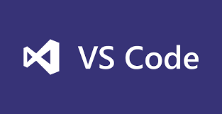

**Learning Outcomes**

* Learn how to install Microsoft “Visual Studio Code (VSCode)

**Resources**

* Visual Studio Code, <https://code.visualstudio.com/>
* Cmd commands under Windows, <https://www.thomas-krenn.com/en/wiki/Cmd_commands_under_Windows>

**Activities**

* Downloading
* Installing
* Testing
* Q&A

**Downloading**

1. Visit <https://code.visualstudio.com/>

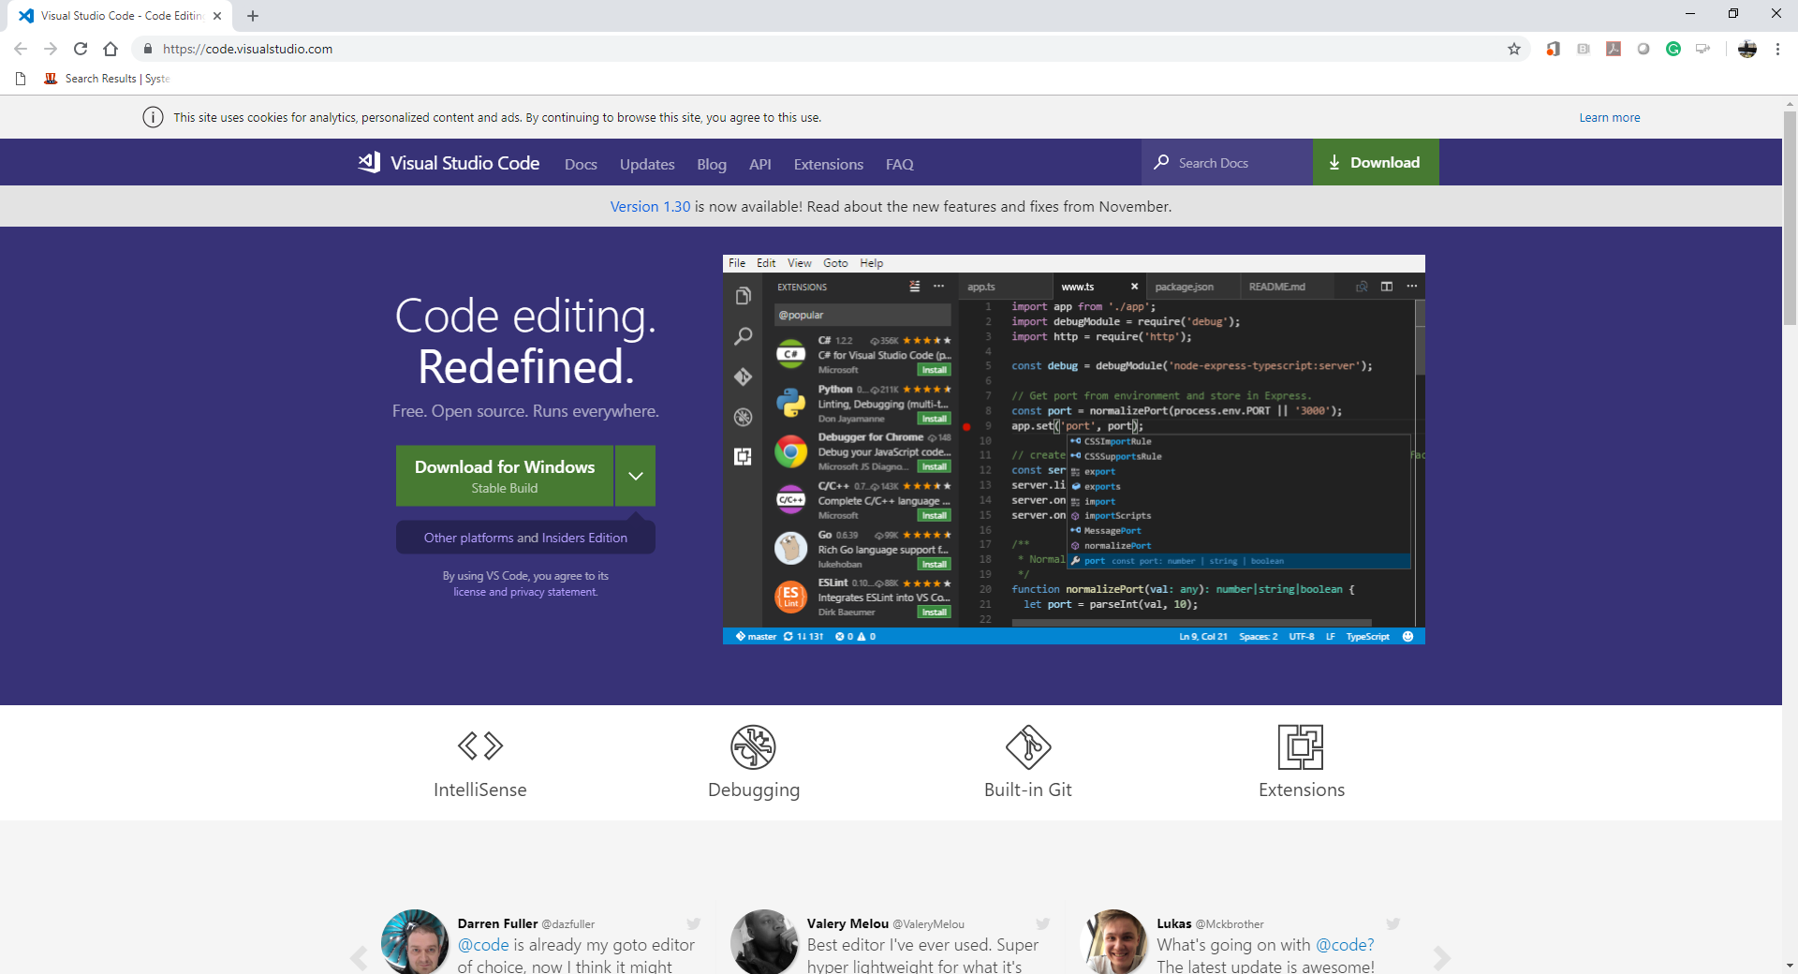

1. Select a correct version for your operating system.  
   For example, you can select “Windows x64” for your Windows 10.  
   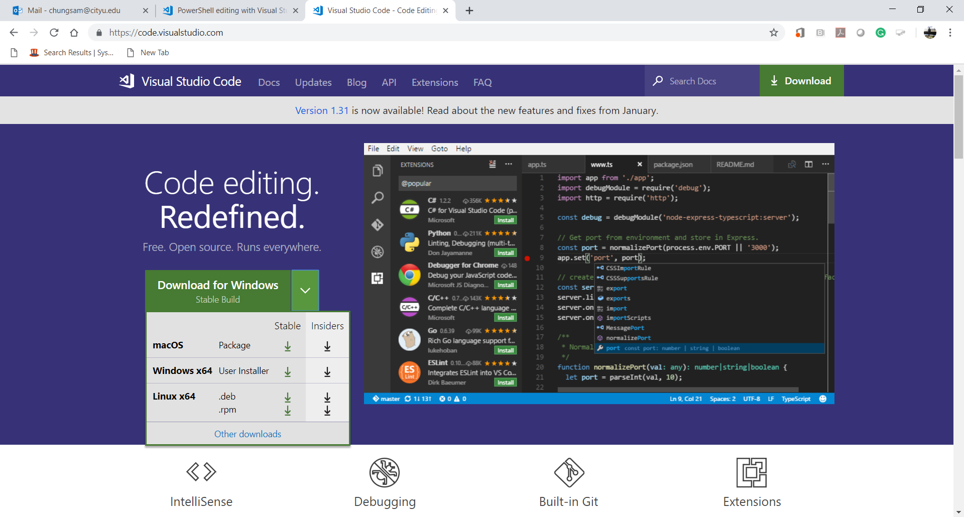
2. Then, you can download “VSCodeUserSetup-x64-1.30.2” for your Windows 10.



1. The “Getting Started” webpage will be displayed.

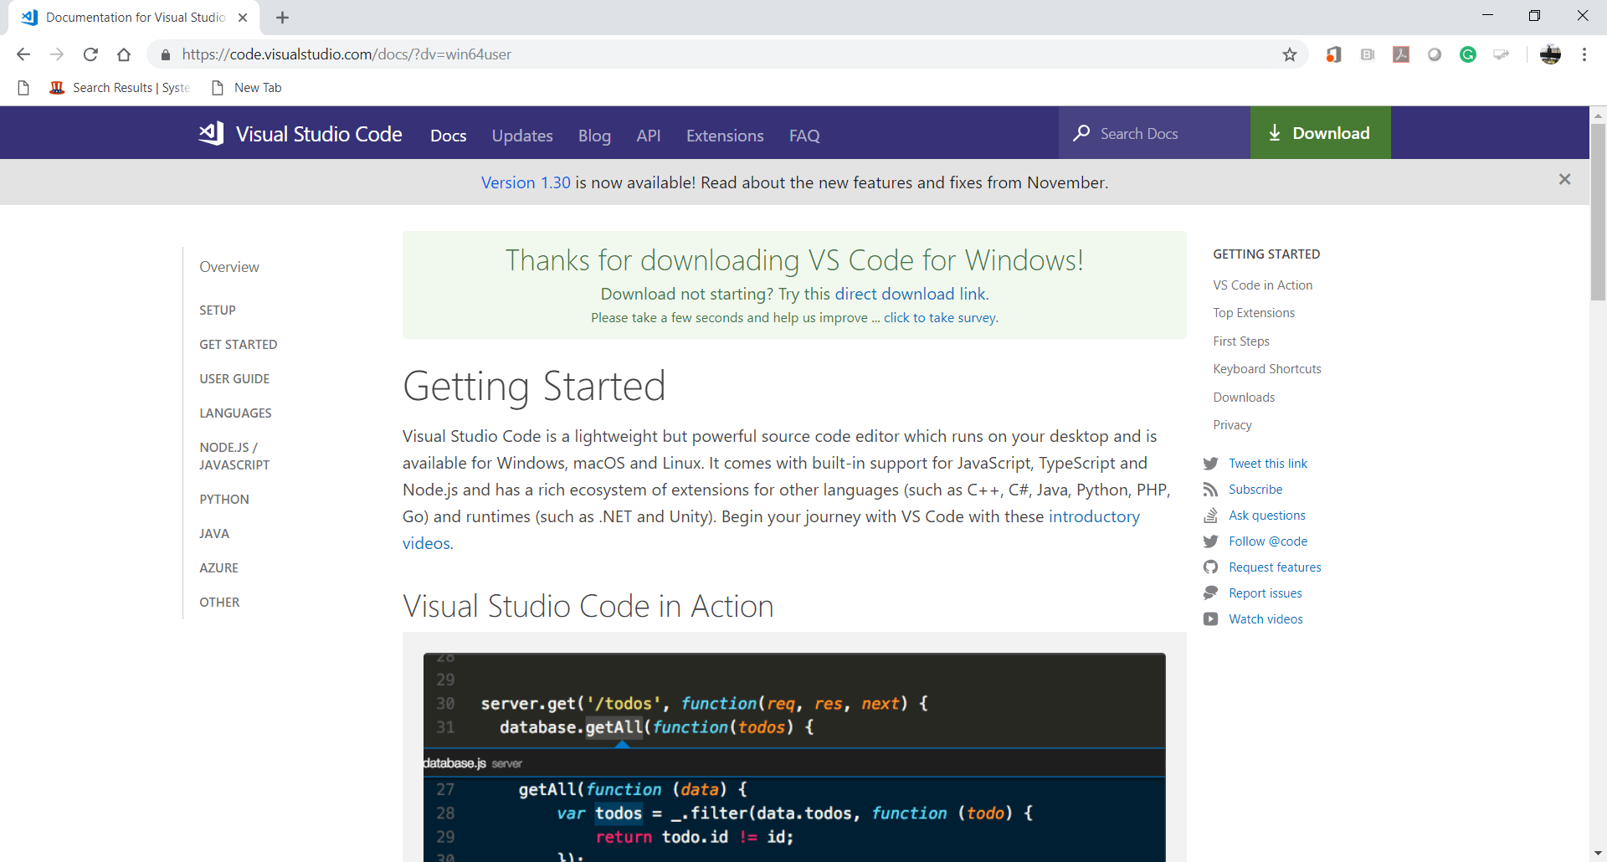

**Installing**

1. Install VSCode.  
   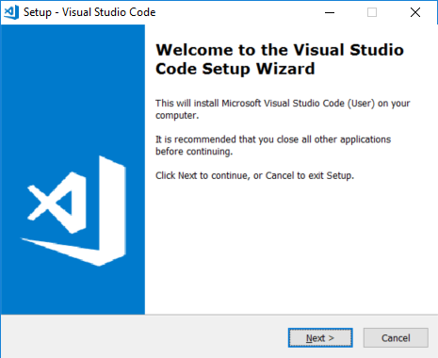

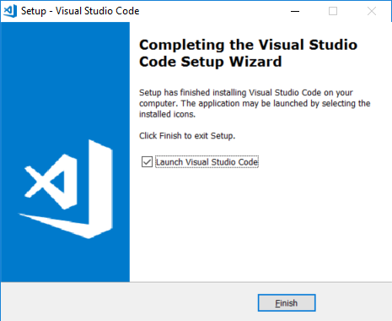  
  
  
  
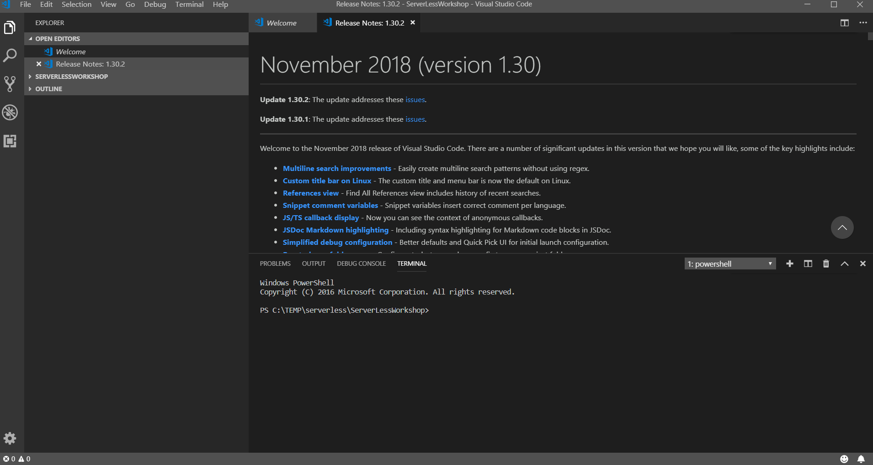

1. After installing the VSCode, close the VSCode.  
   Go to “File” menu end select ‘Exit” menu item.

**Testing**

1. Open the VSCode.  
   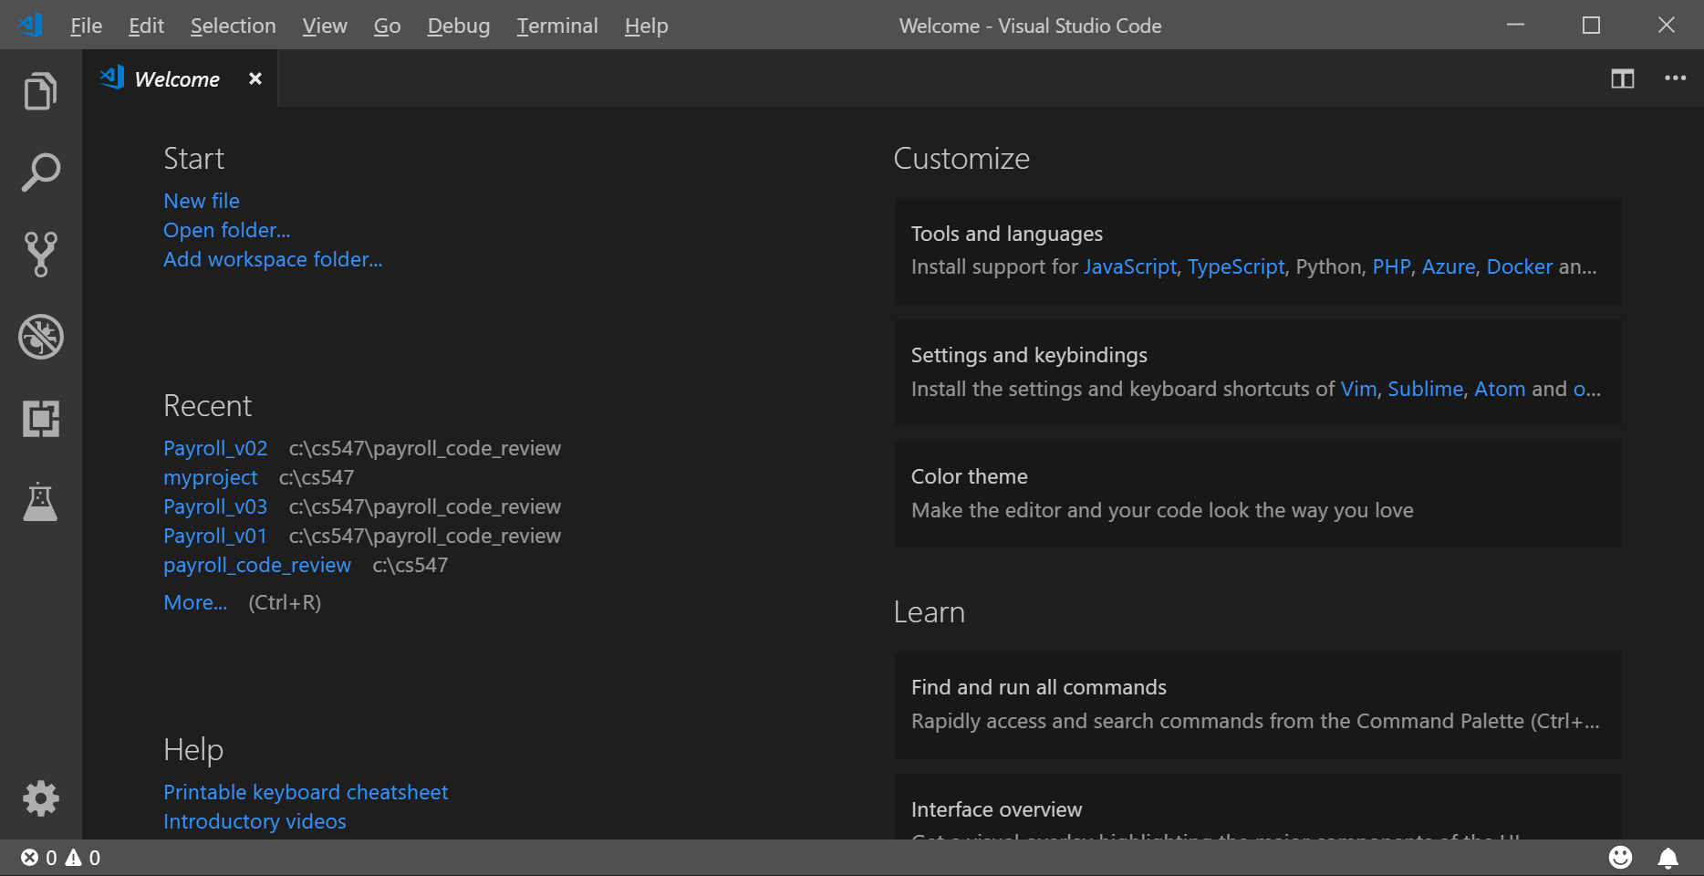
2. Go to “View” menu and select “Terminal” menu item for your Command Line Interface (CLI).  
   Or you can type “Ctrl+~”  
   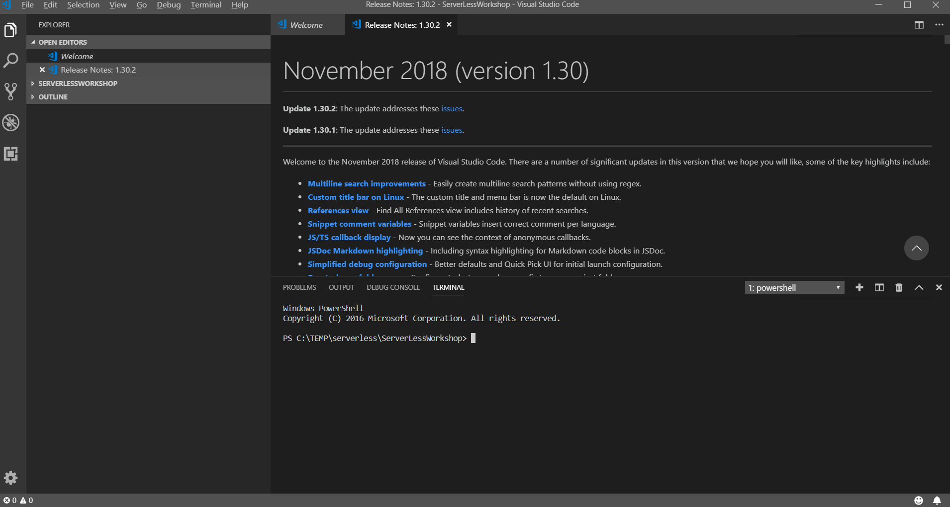
3. Go to the root directory of your disk drive.  
   Create a working directory called “isec505” for your course and move to the directory.  
   The following commands under Windows will be used.  
   >> cd /  
   >> mkdir isec505  
   >> cd isec505  
   >> dir  
    For more information about Windows commands, please visit <https://www.thomas-krenn.com/en/wiki/Cmd_commands_under_Windows>   
     
   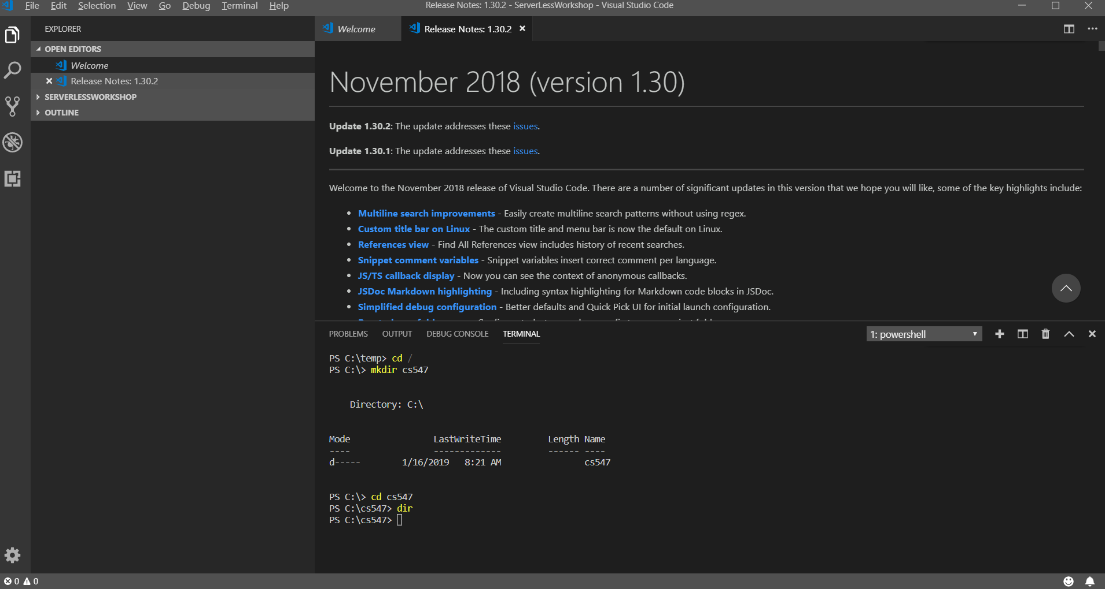
4. Clear your CLI.  
   >> cls
5. Close the VSCode.

**Q&A**  
Justify your answers with at least one reference.

1. What is Visual Studio Code?  
     
   It is a lightweight terminal, text editor, syntax highlighter that has auto code completion, debugger, and compiler.
2. Why do you use the Visual Studio Code instead of Visual Studio (Community edition)?

I actually use Visual studio normally when I work on C, C++, and C#.